Molly Lopez

Writing Samples

mollyjanemcg@yahoo.com

404-376-7193

Writing Samples

Contents

One Pager slides 3

Two Pager Slides 4

Architecture Diagrams 5

System Help SharePoint Pages 6

Bastion Health Dashboard Guide 6

Knowledge Center 7

Site Maps 8

Overview 9

Pipelines 10

Dashboards 11

Dashboards Details 12

Process Pages 13

AWS Get Started process pages: 13

Support Instructions for AWS 14

Migrating AWS Account 15

IPAM 16

Onboard New Infosys Team Members 17

Decks and Slides 18

Before and after examples: 19

Before 19

After 19

Before 20

After 20

Before 21

After 21

Articles 22

AKS Upgrade 22

RHEL Release 22

SSP Release 23

SSP Release 23

Monitoring Podcast weekly series article 24

Release Notes 25

AWS 25

SSP 26

OCI 27

SharePoint Form Development 28

Source Material to Finished Deliverable Examples: 29

Source Material 29

Deliverable 29

Source Material 30

Deliverable 30

Source Material 31

Deliverable 32

Source Material 33

Deliverable 33

Source Material 34

Deliverable 34

One Pager slides 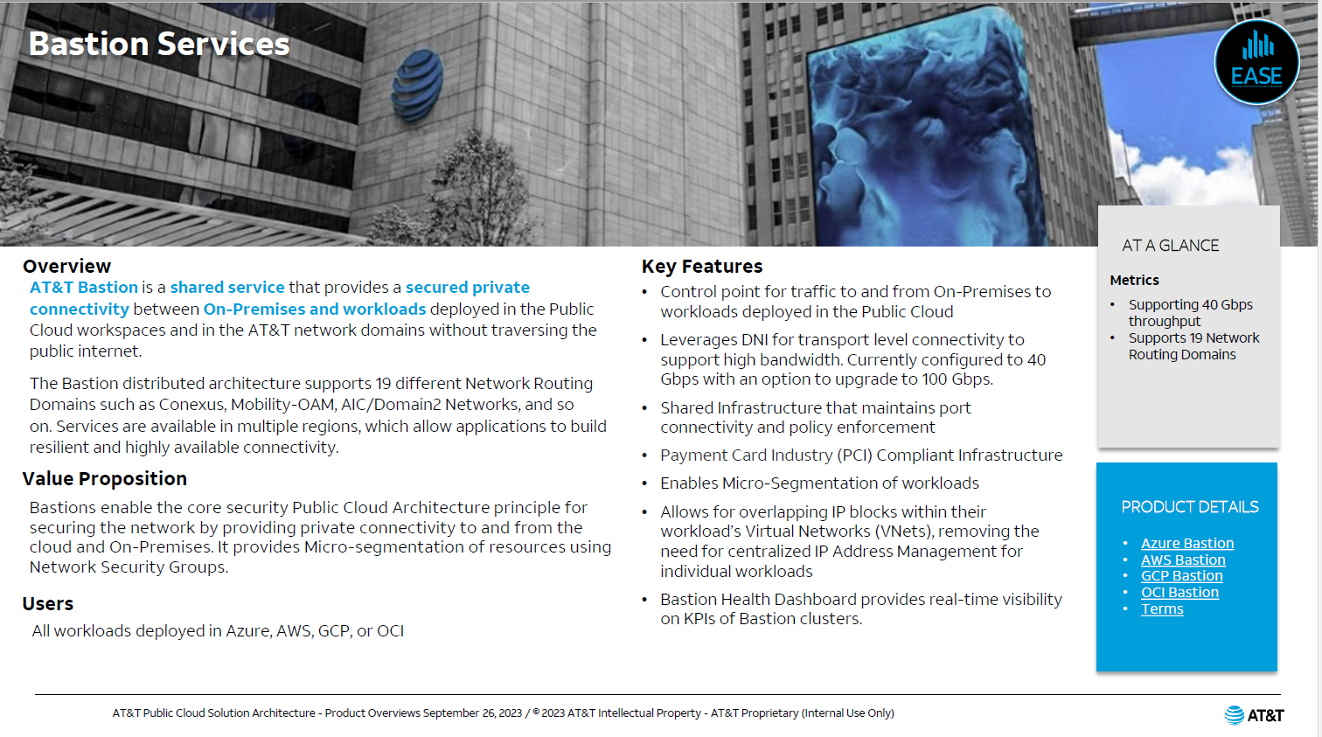 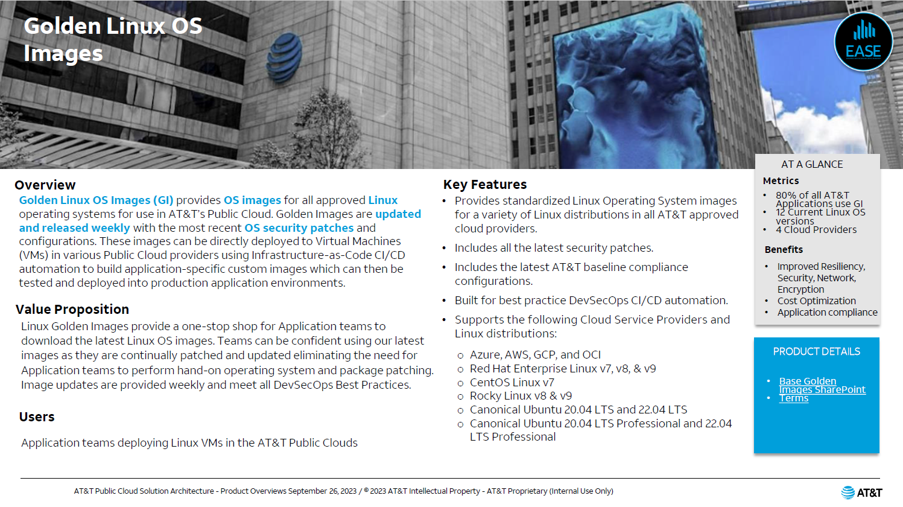

## Two Pager Slides

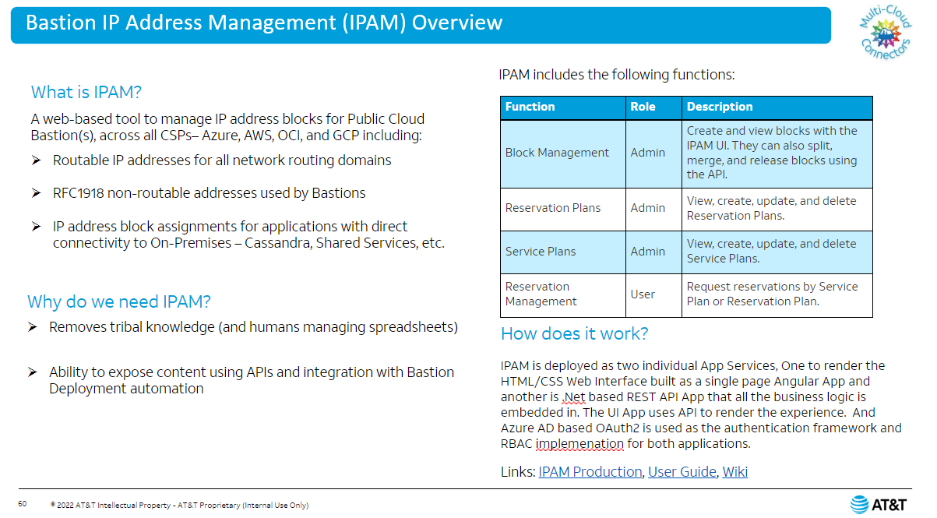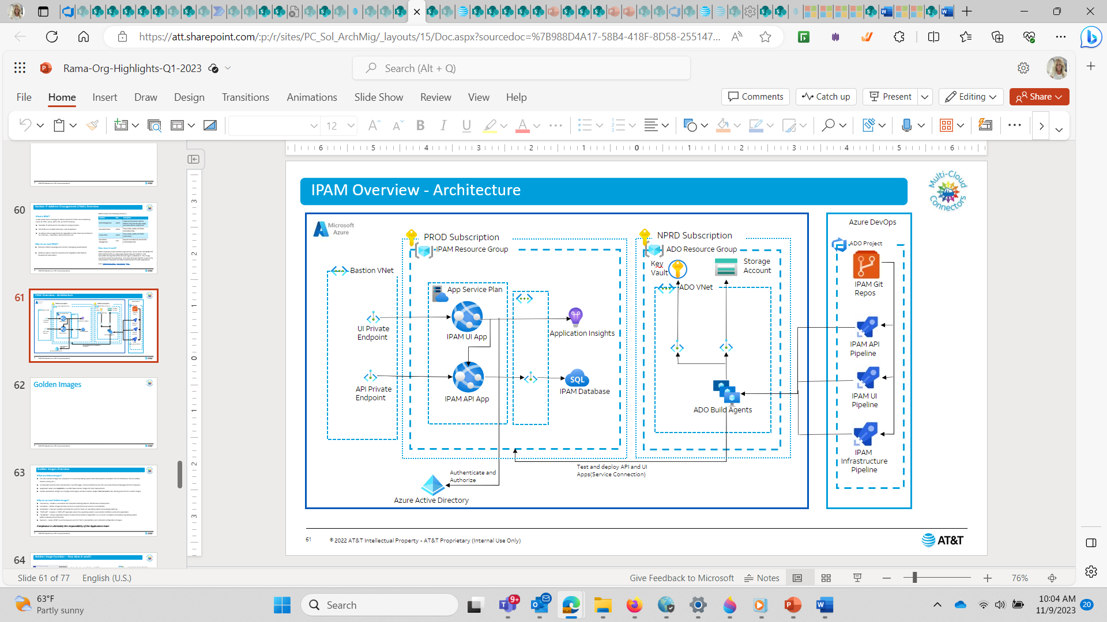

## Architecture Diagrams

**Before** (This is an example of source material):

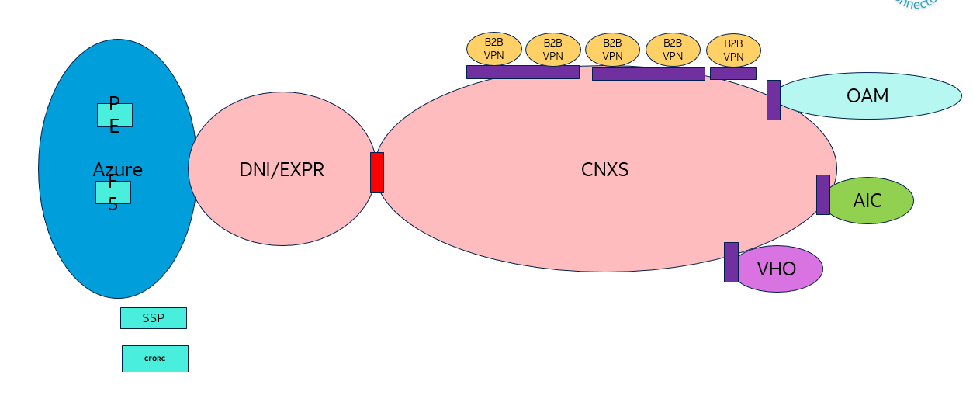

**After**:

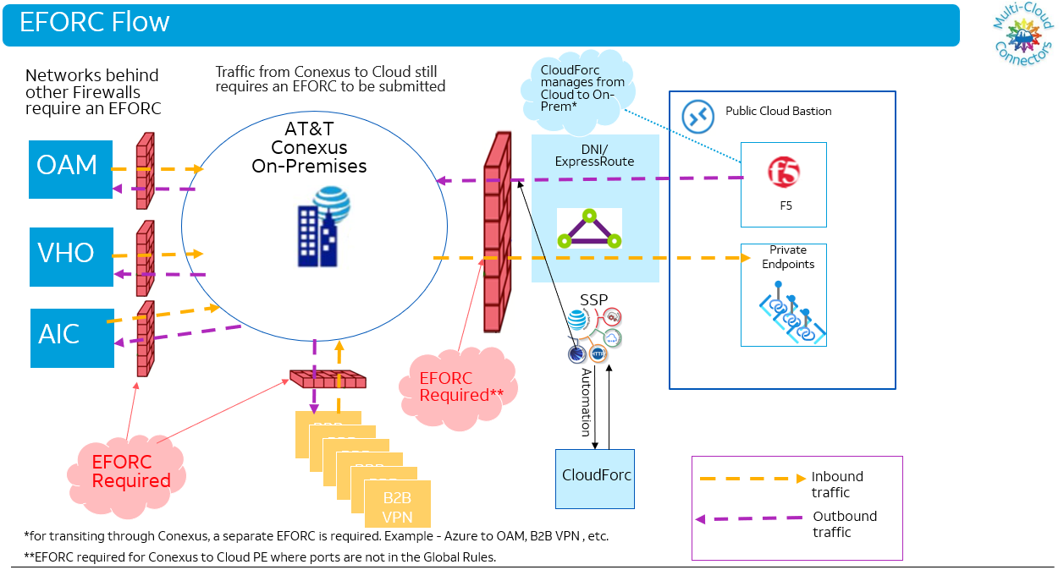

## System Help SharePoint Pages

### Bastion Health Dashboard Guide

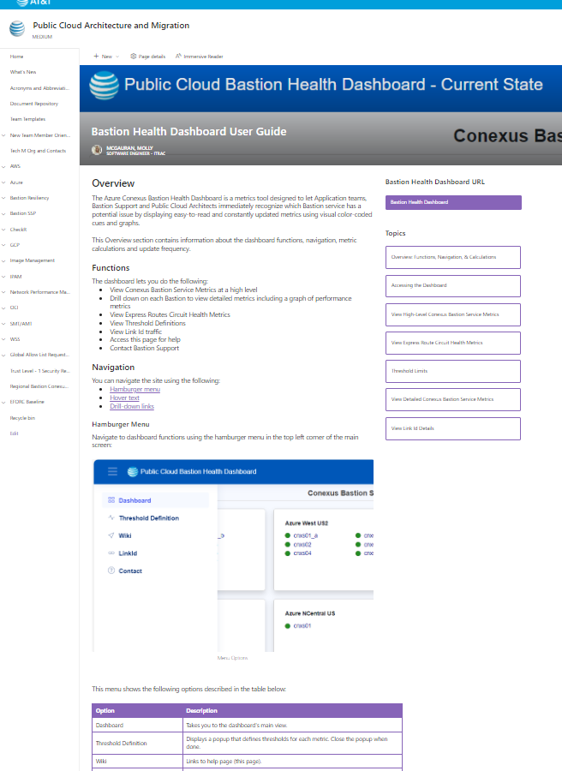

### Knowledge Center

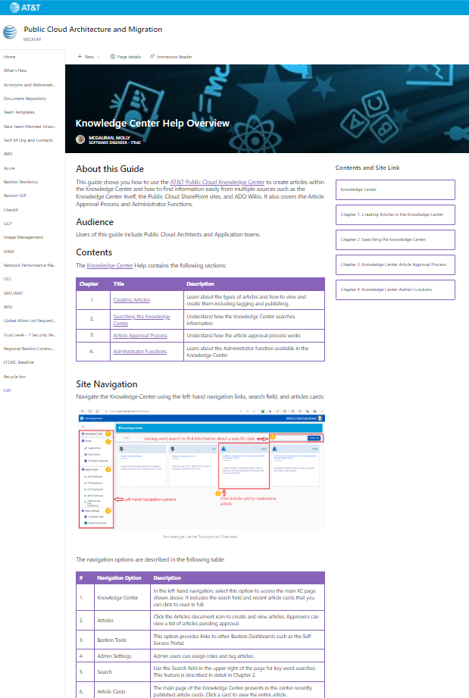

# Site Maps

Implemented Site Maps for each Track’s Documentation Starting with OCI:

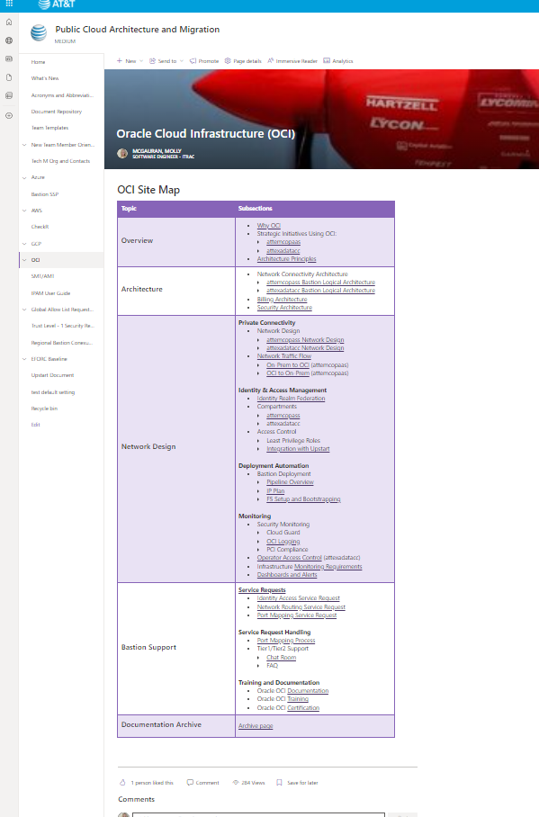

## Overview

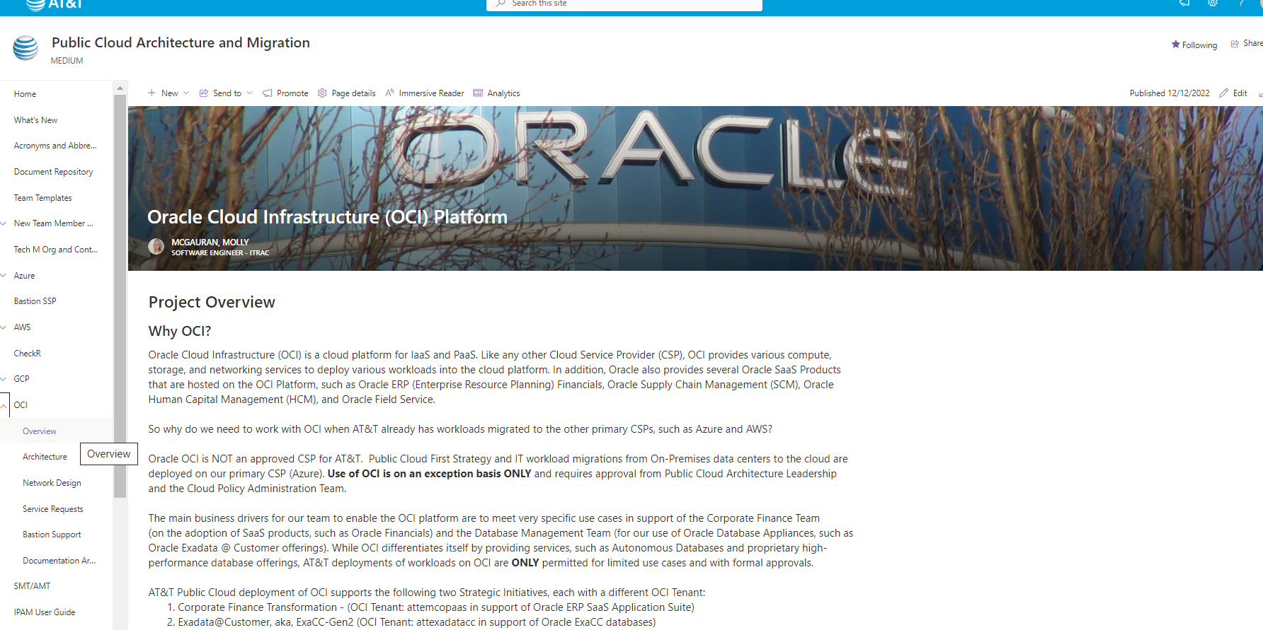

## Pipelines

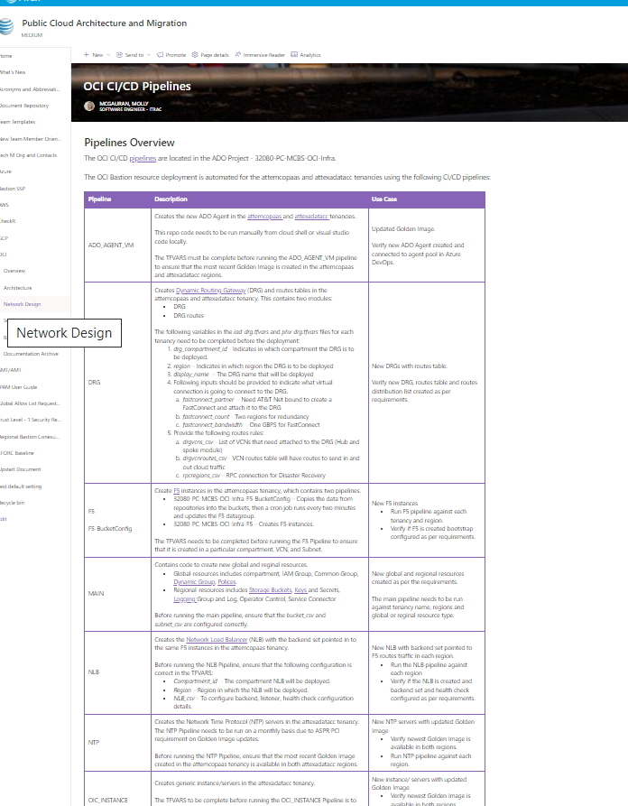

## Dashboards

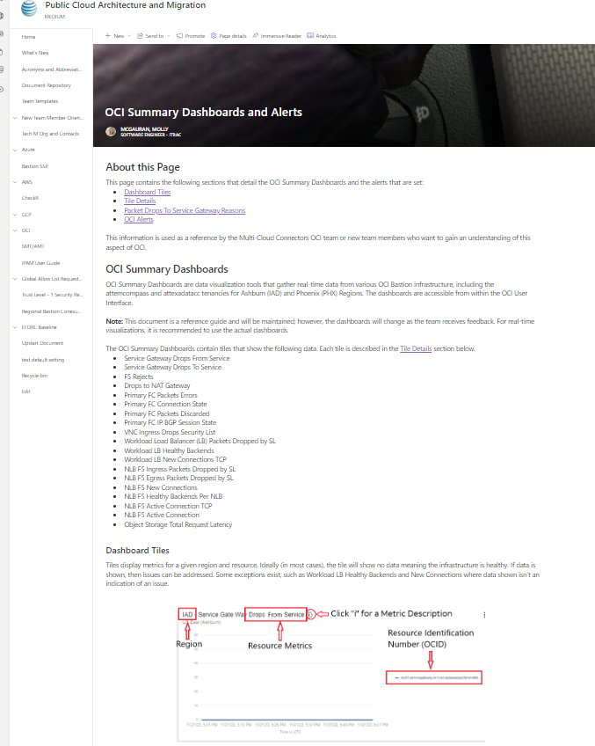

## Dashboards Details

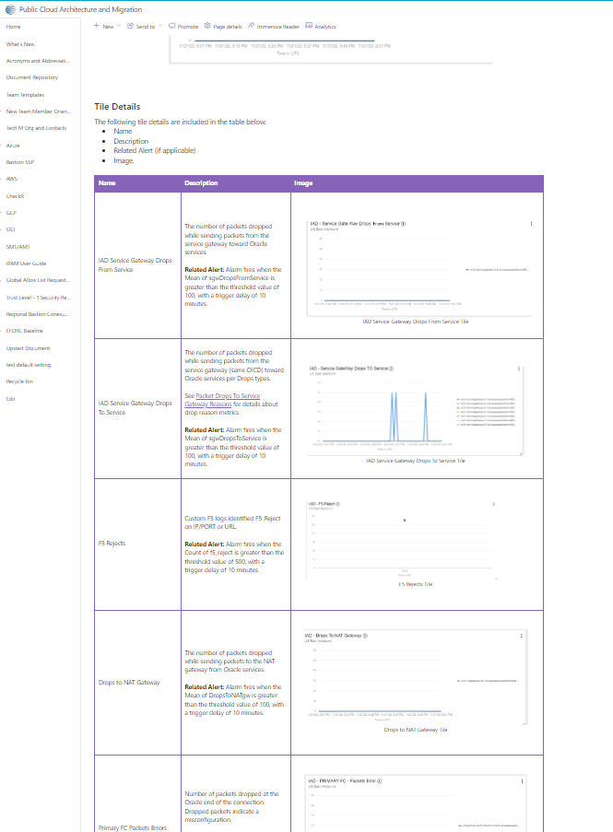

# Process Pages

## AWS Get Started process pages:

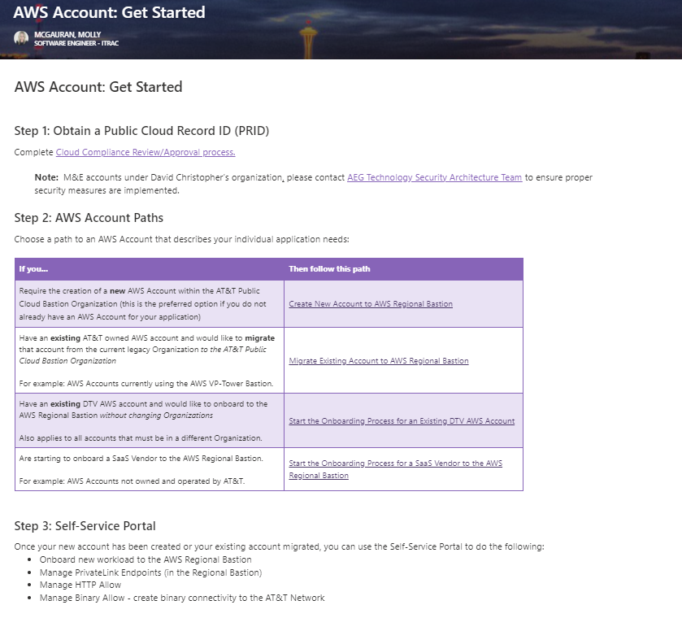

## Support Instructions for AWS

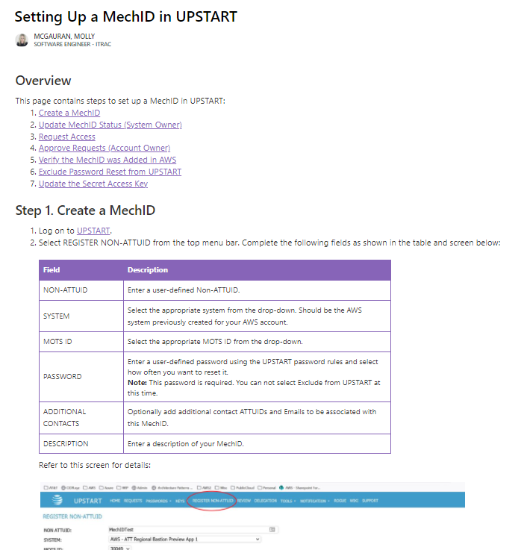

## Migrating AWS Account

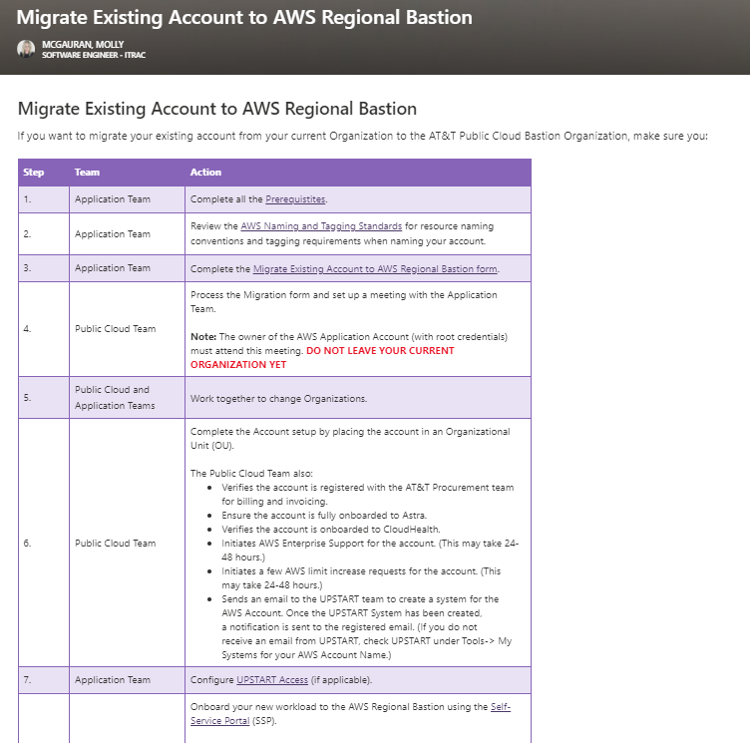

## IPAM

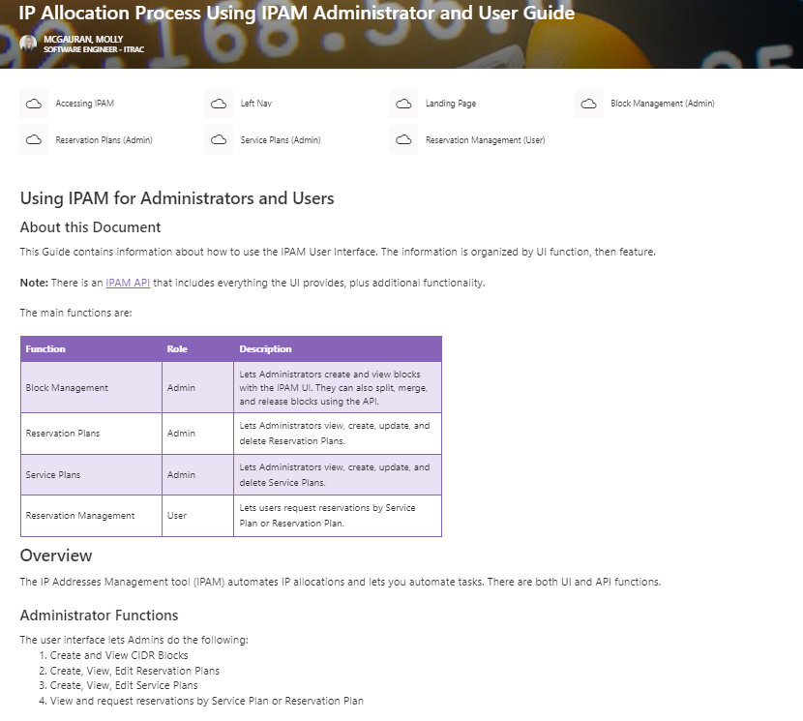

## Onboard New Infosys Team Members

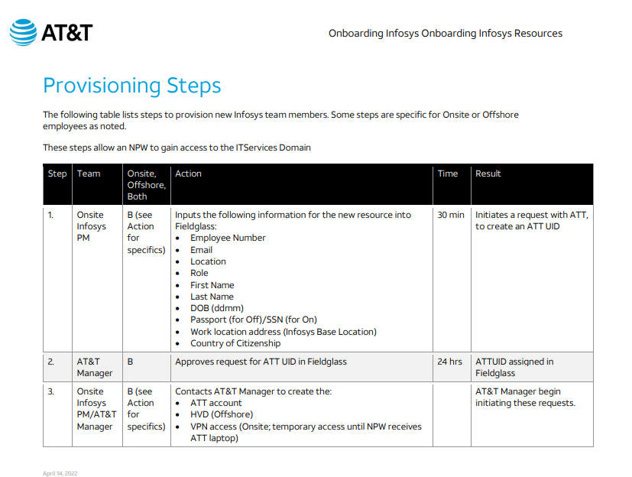

# Decks and Slides

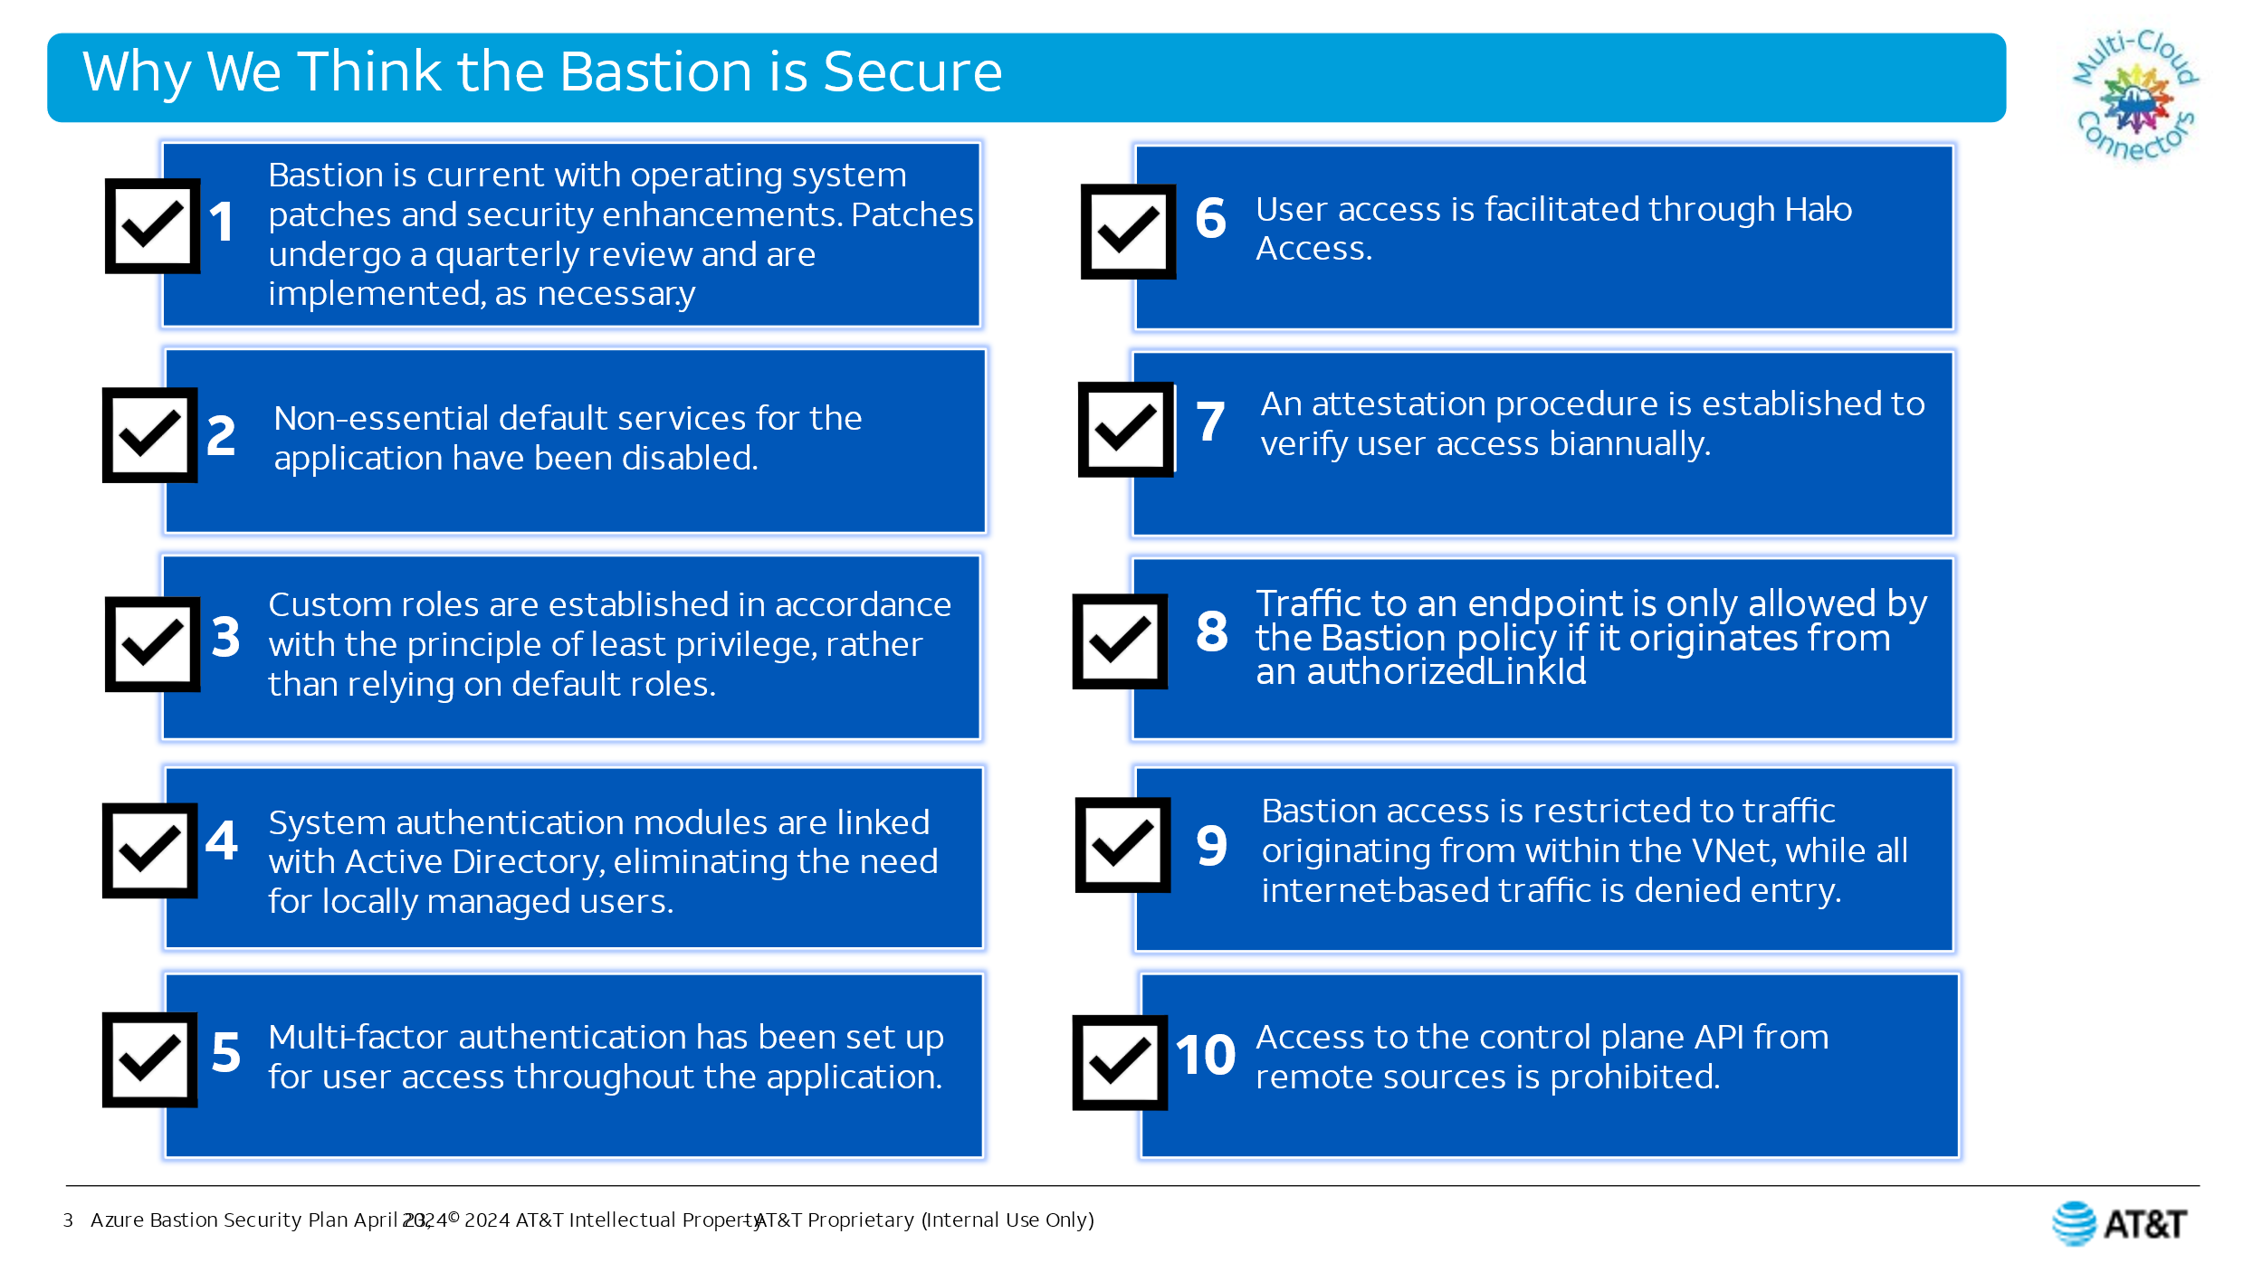

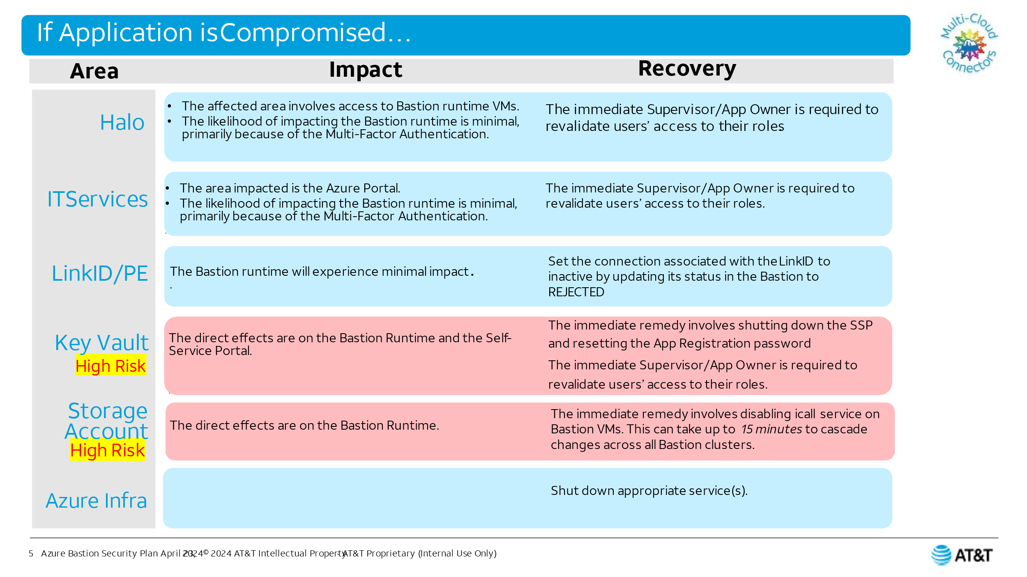

## Before and after examples:

### Before

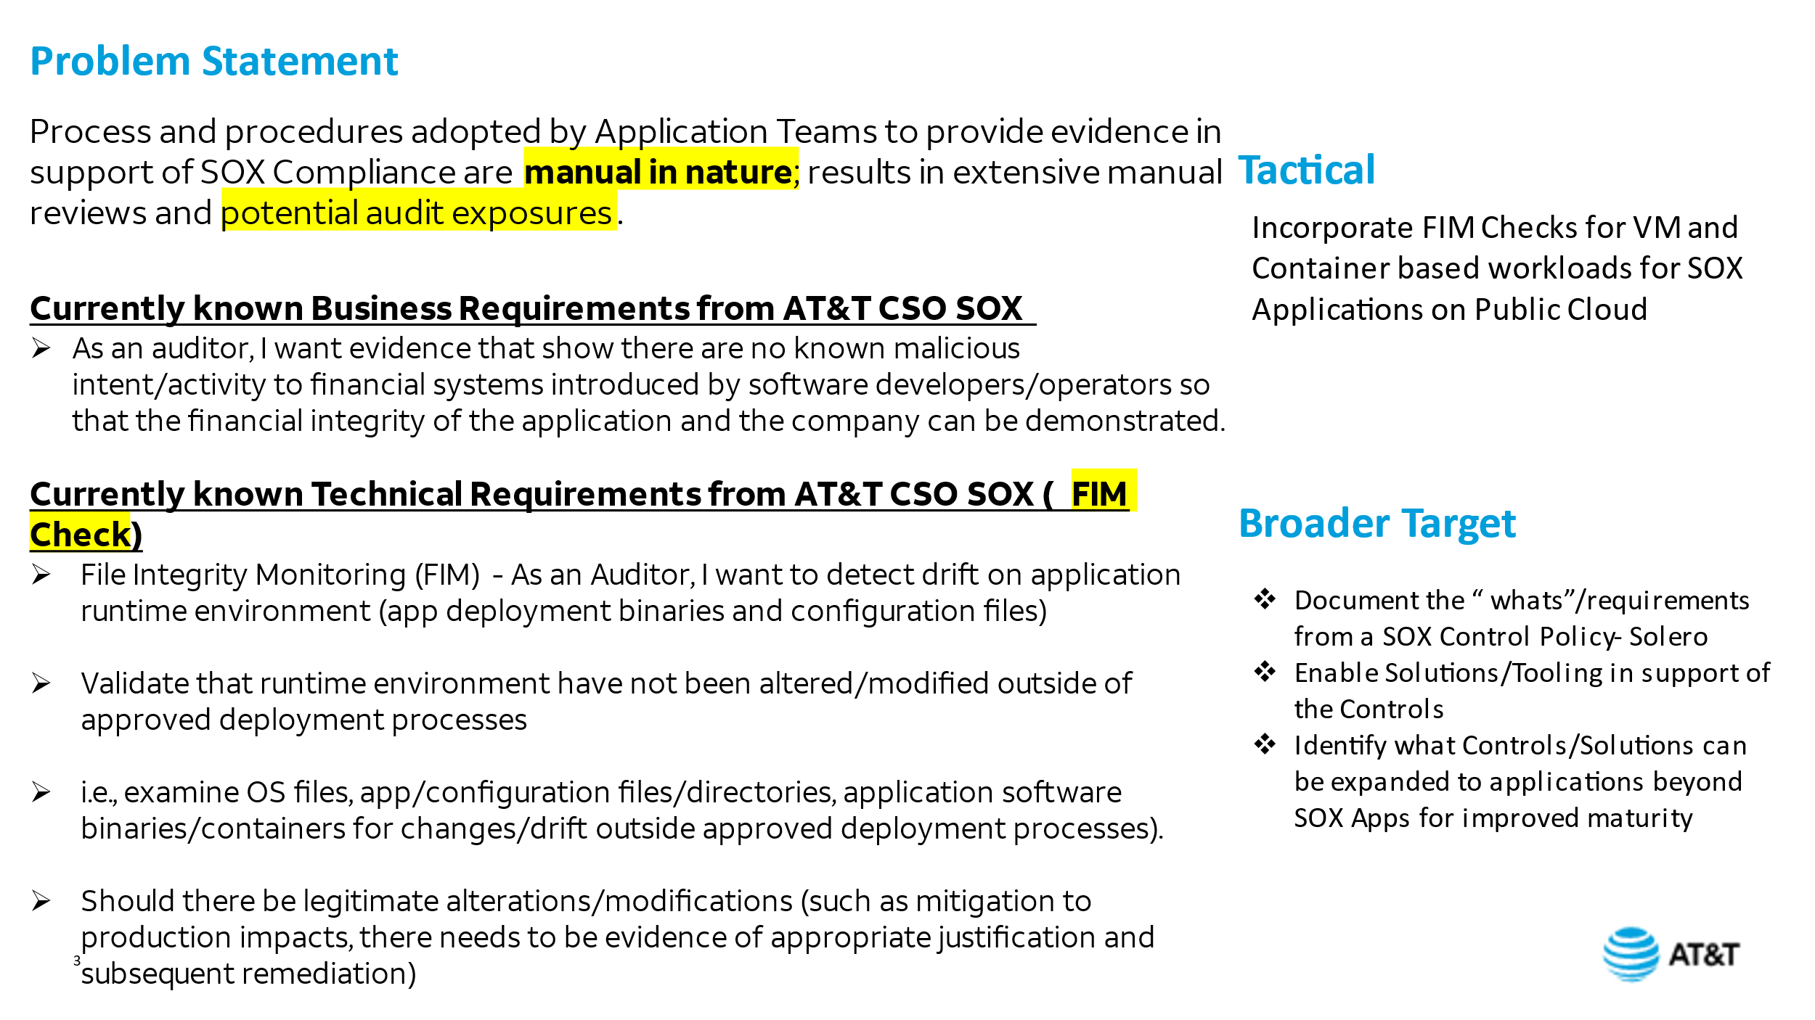

### After

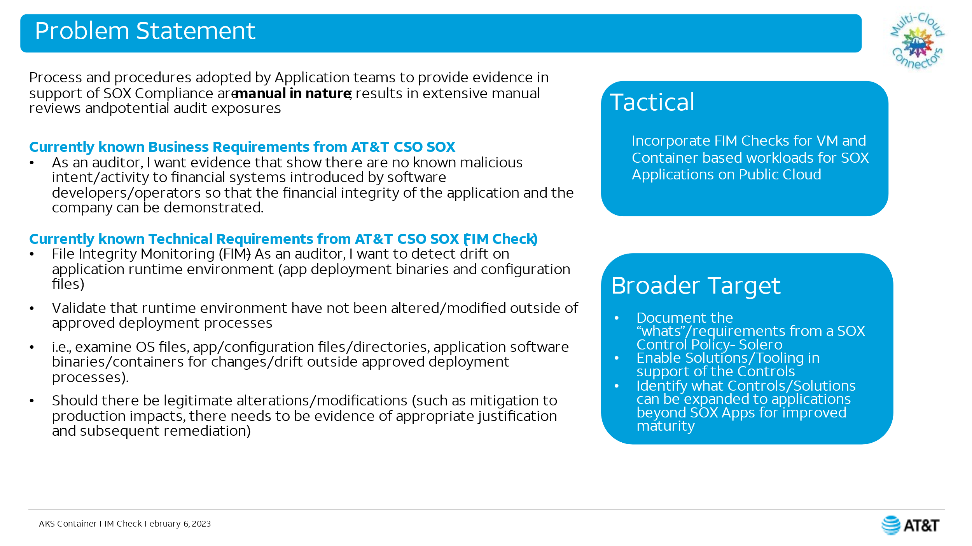

### Before

There were three similar flow charts originally like this one:

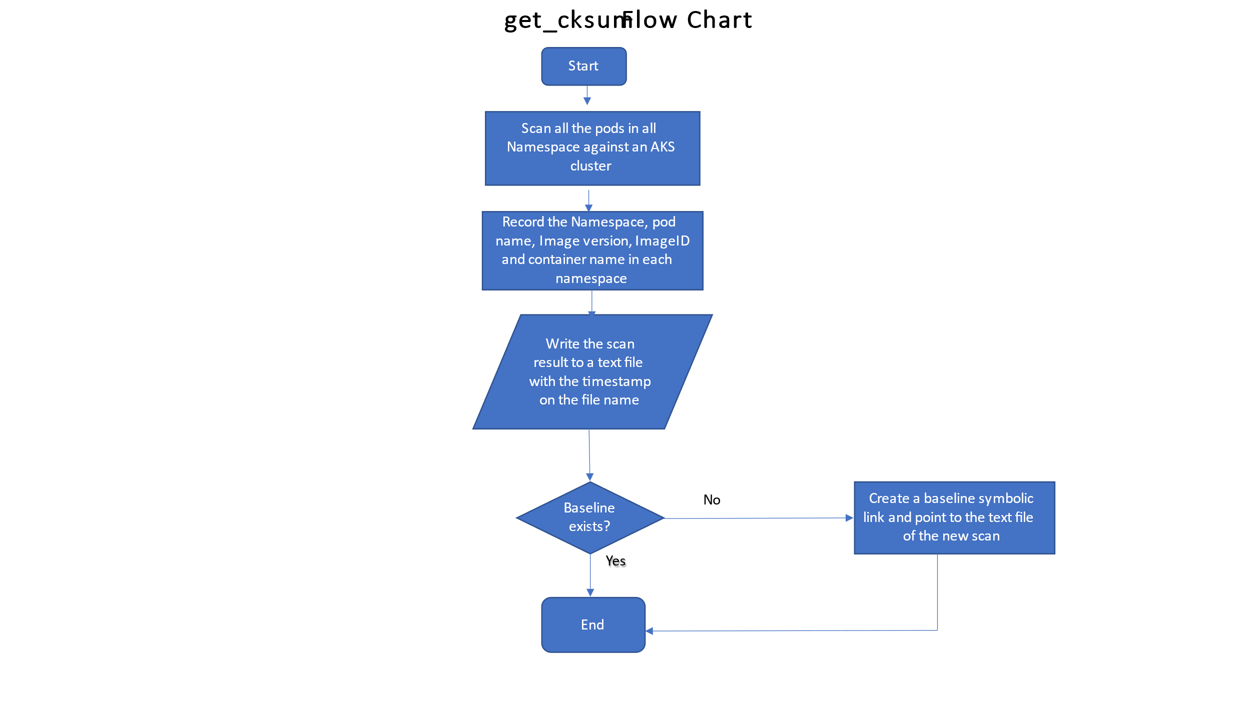

## After

Combined into one slide:

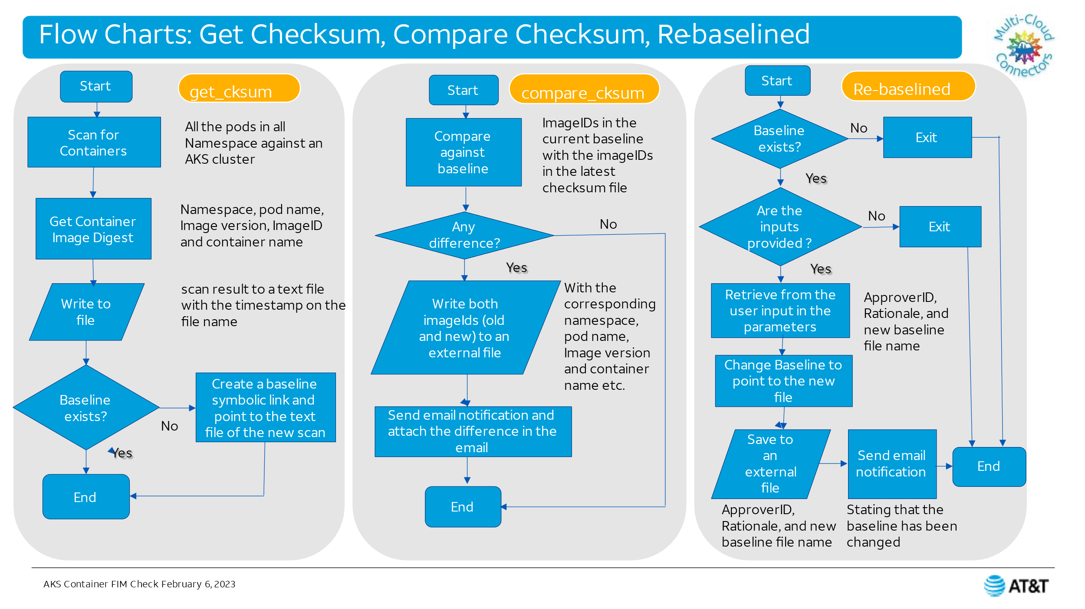

### Before

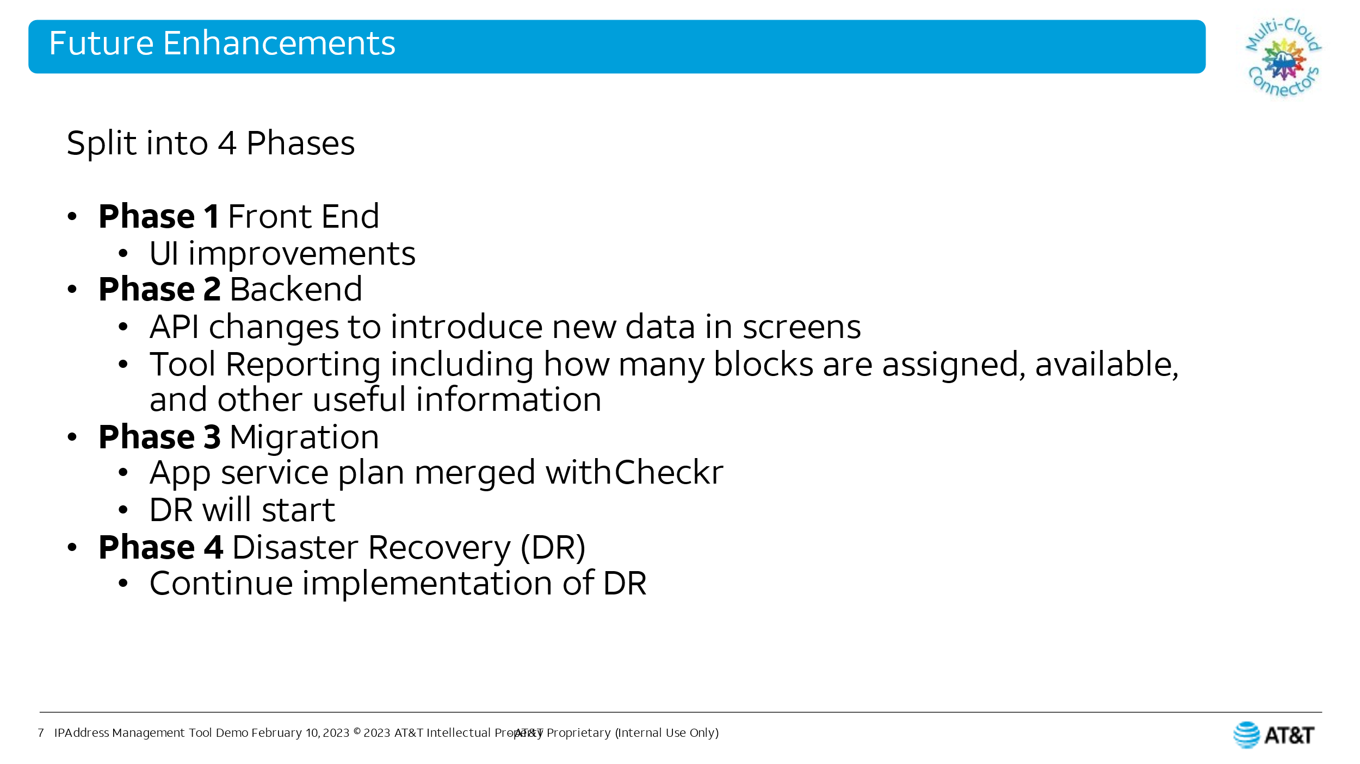

### After

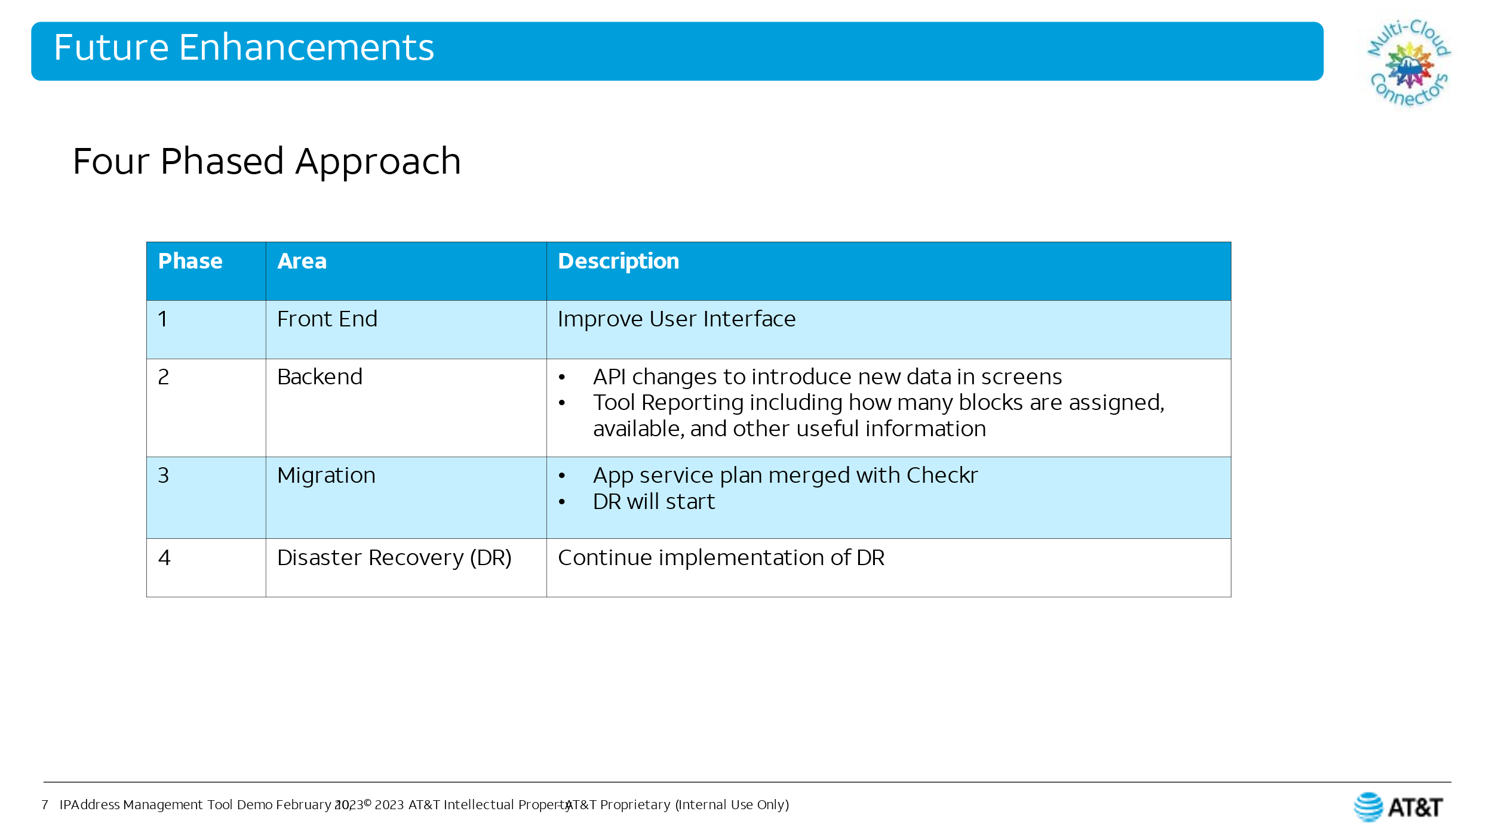

# Articles

## AKS Upgrade

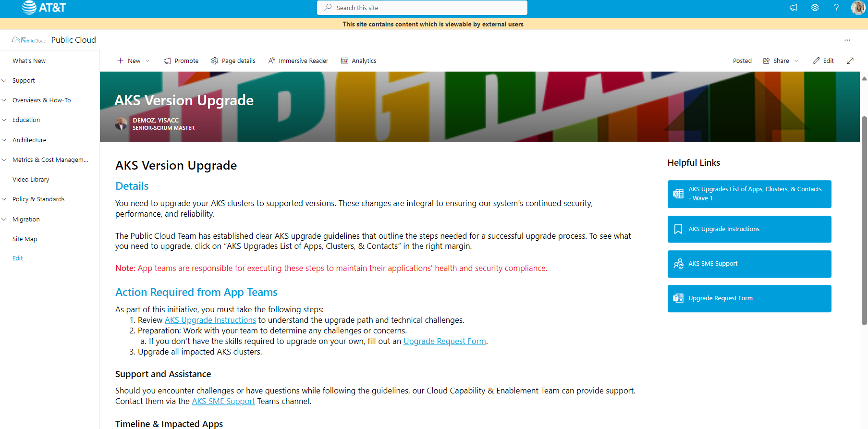

## RHEL Release

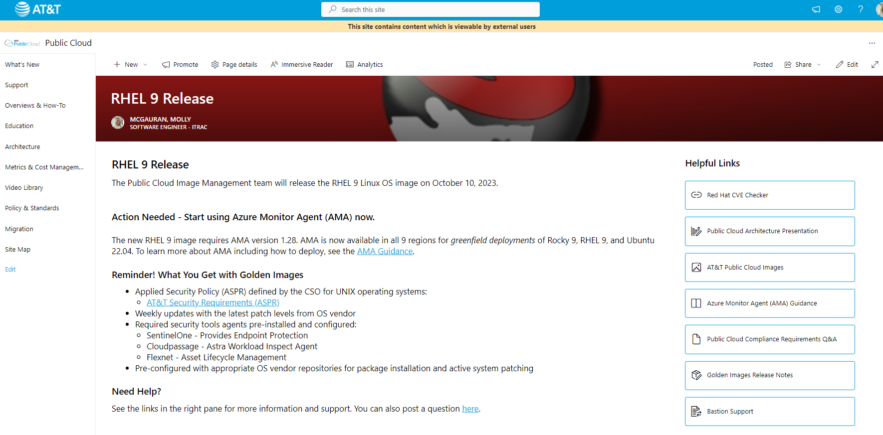

## SSP Release

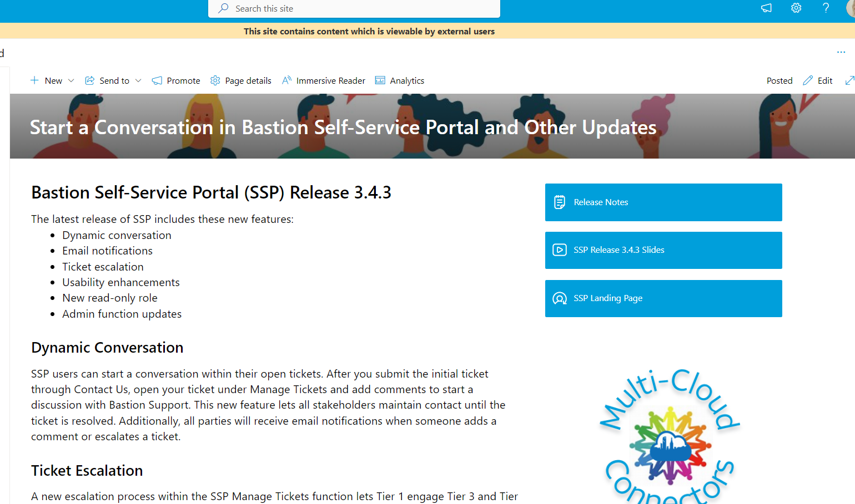

## SSP Release

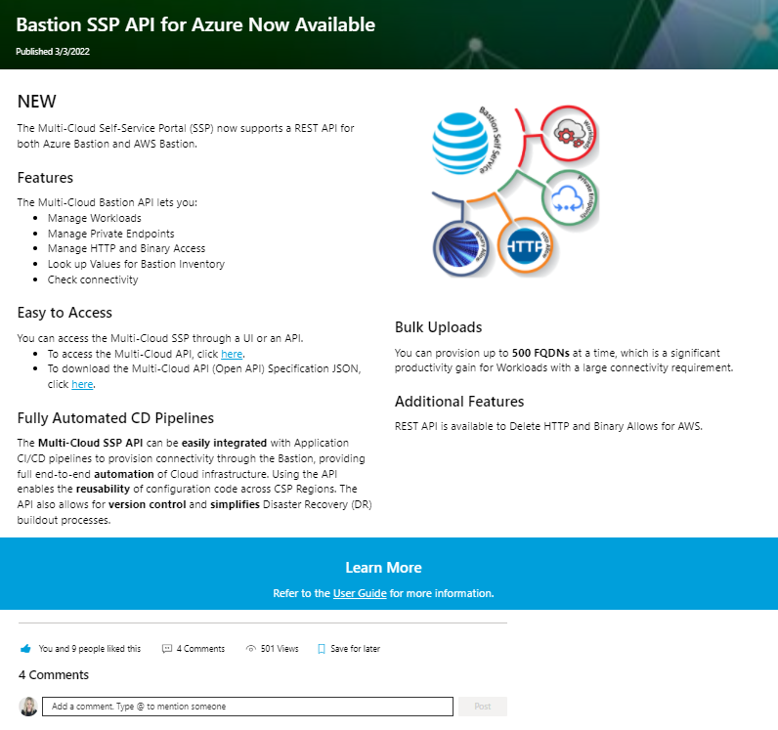

## Monitoring Podcast weekly series article

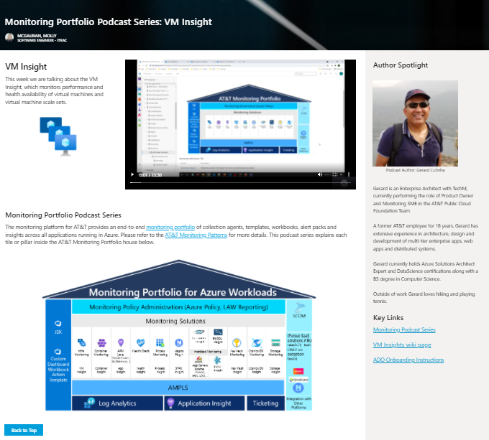

# Release Notes

Publish updates for each project when they deploy to prod.

## AWS

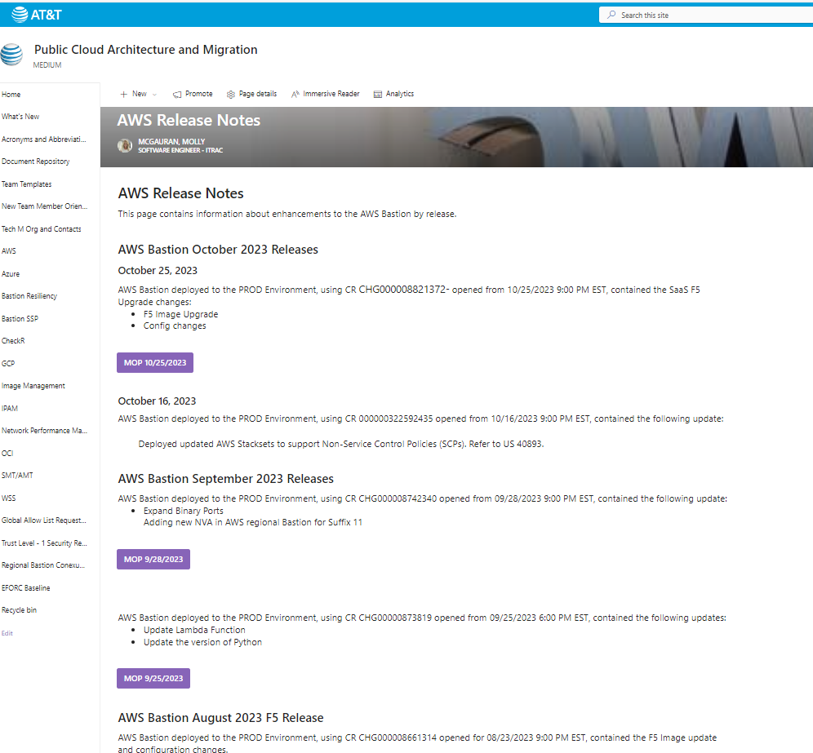

## SSP

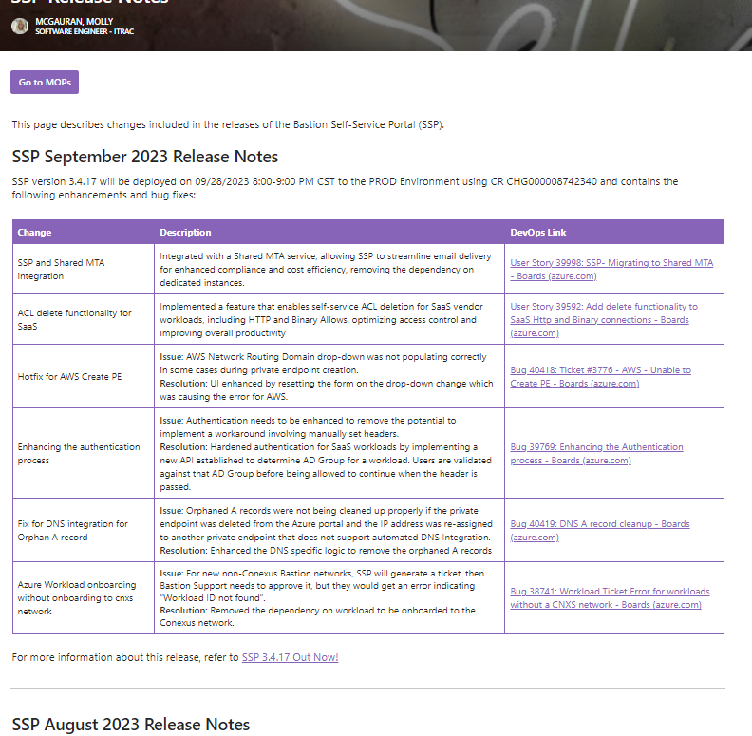

## OCI

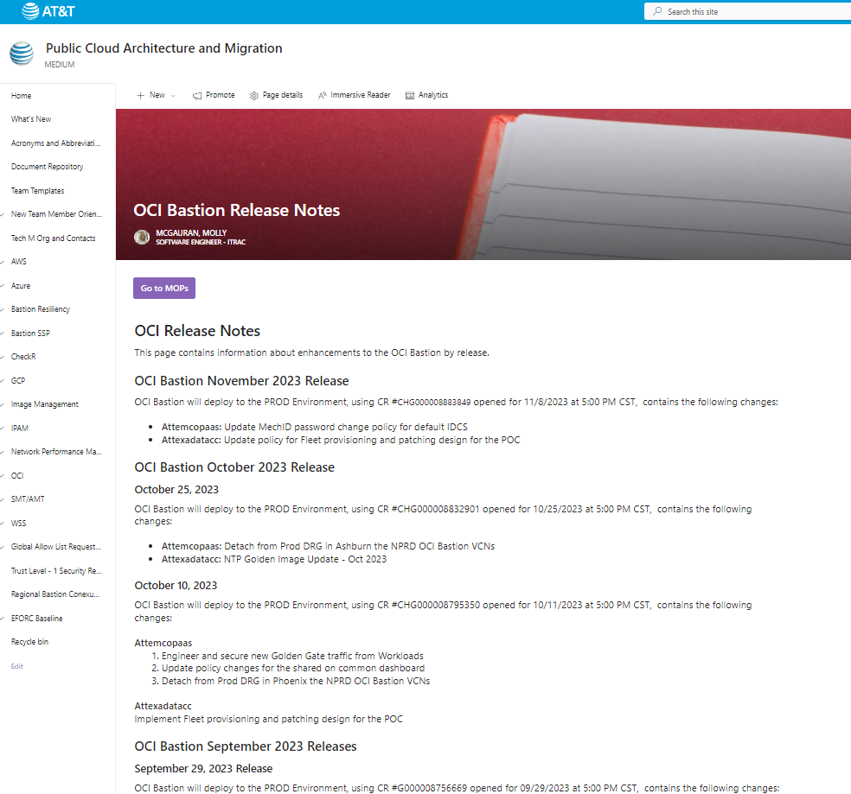

# SharePoint Form Development

Port Mapping Request customized in Power Apps and tied to a Power Automate workflow: Once submitted triggers email notification to implementation team to work request and also sends notice to the user.

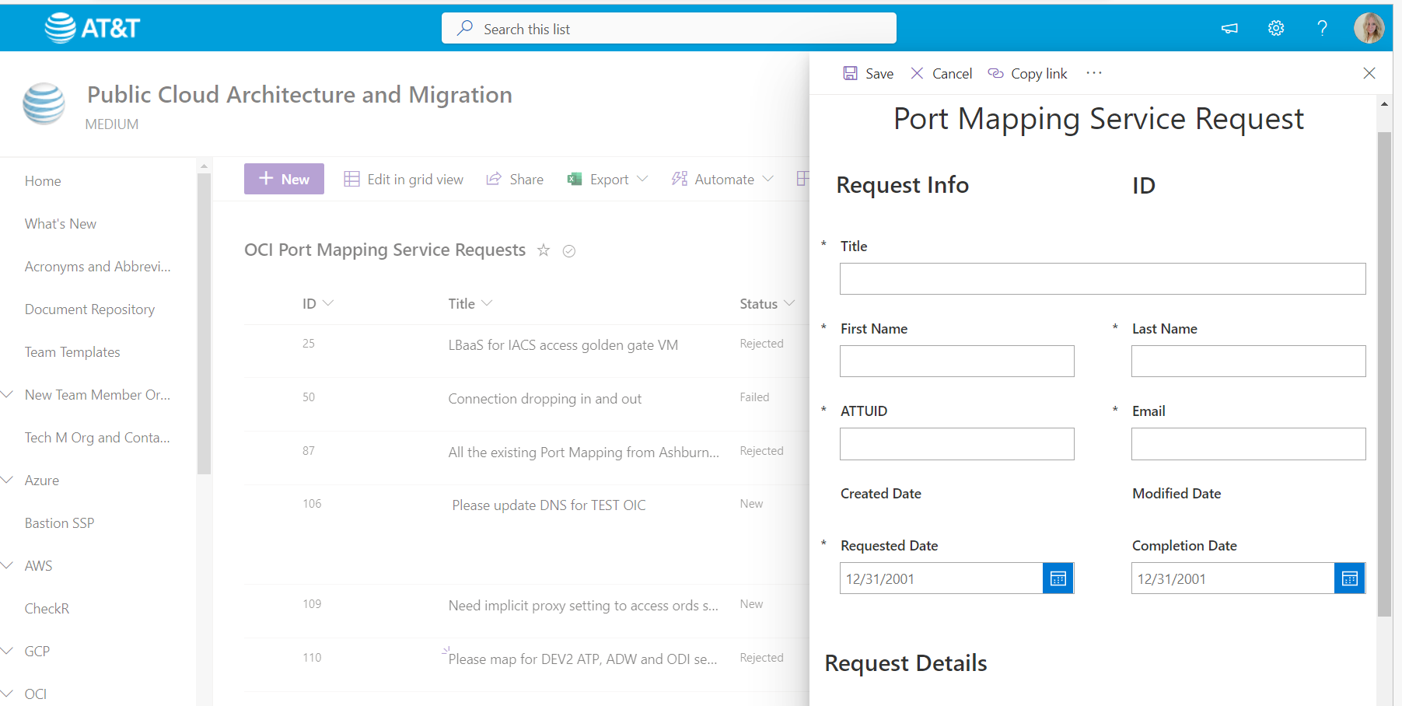

# Source Material to Finished Deliverable Examples:

## Source Material

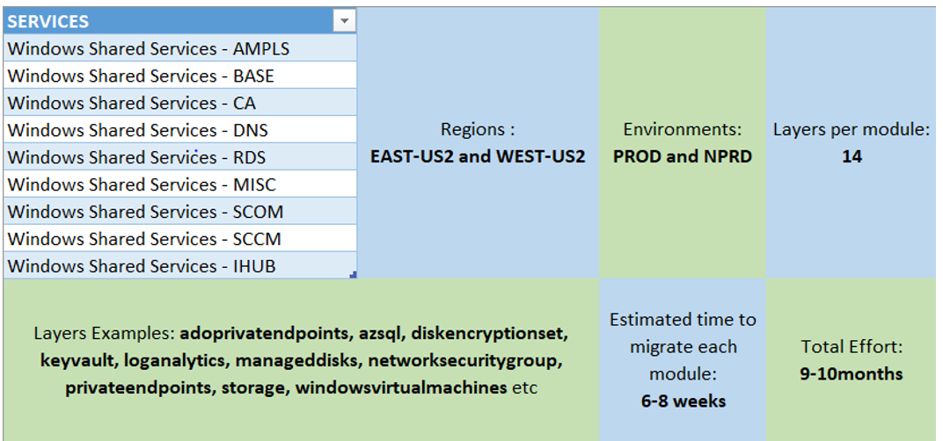

## Deliverable

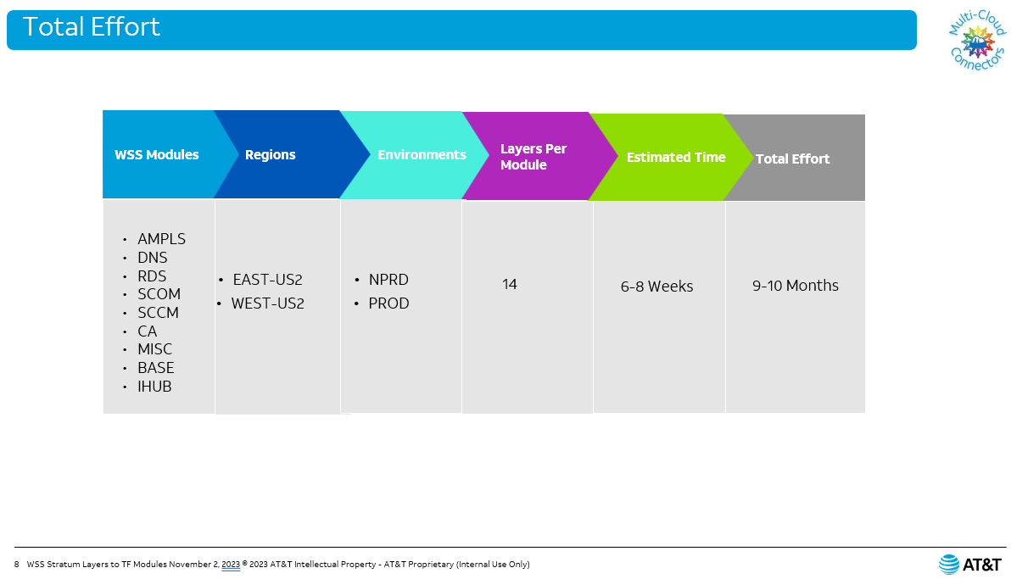

## Source Material

**Step by step:**

* Resources were initially deployed using the old pipelines which are based on the Stratum layers in the WSS-Non Prod Environment(POC-04)
* Now we use the newly created pipelines to run the “terraform import” on the resources deployed though the Stratum layers to get them imported into a new state file(another container for Terraform Modules).
* After importing, the terraform plan shows the deviation from the deployed infra(via stratum) and the modules-states if there are any changes.
* Make sure in the terraform plan, nothing is being impacted on the existing resources.
* However, evaluate the new additions like tag changes and resources that are getting newly created like a null-resource, role-assignments etc.

## Deliverable

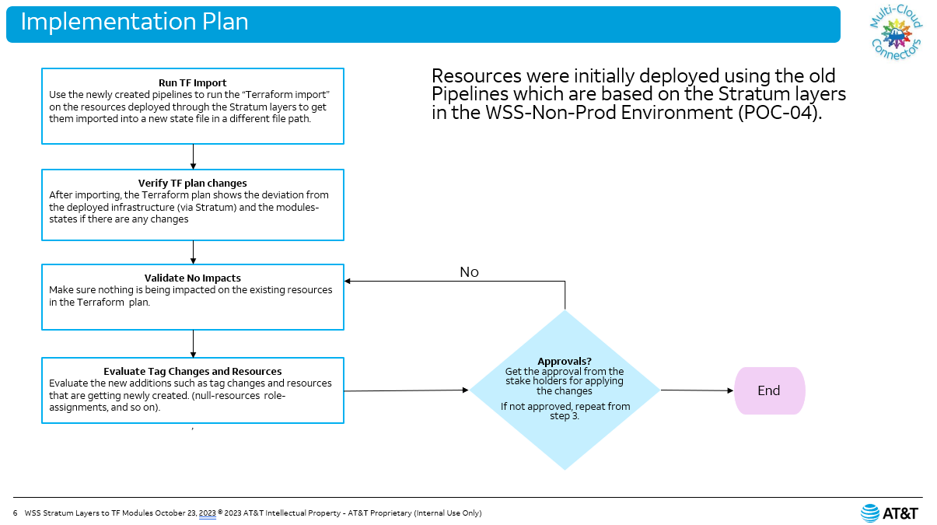

## Source Material

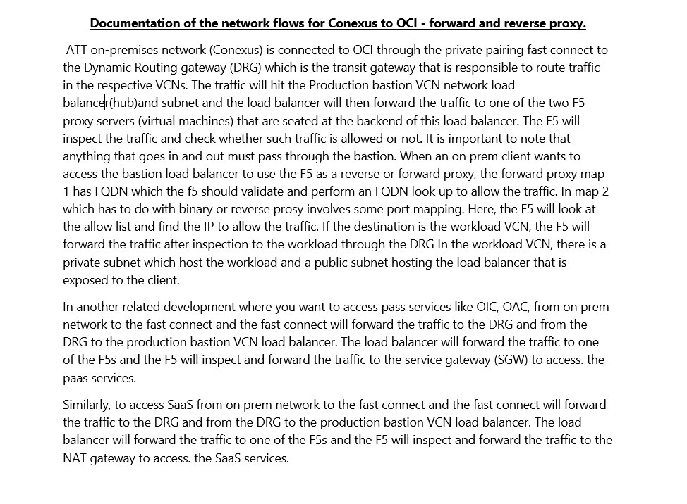

## Deliverable

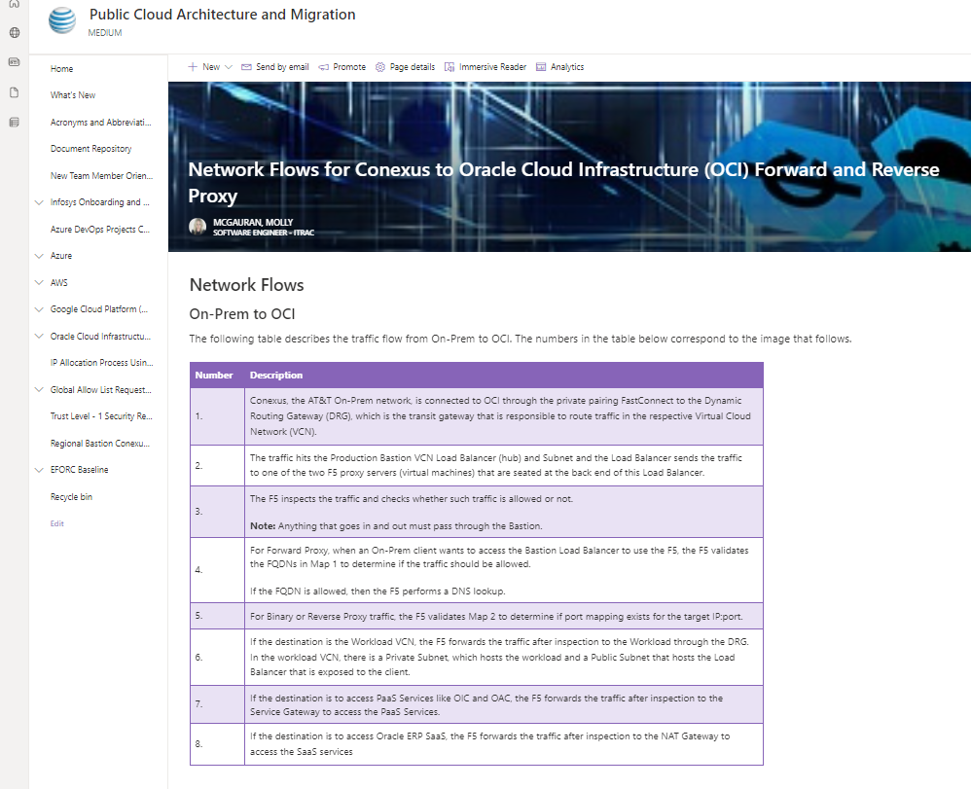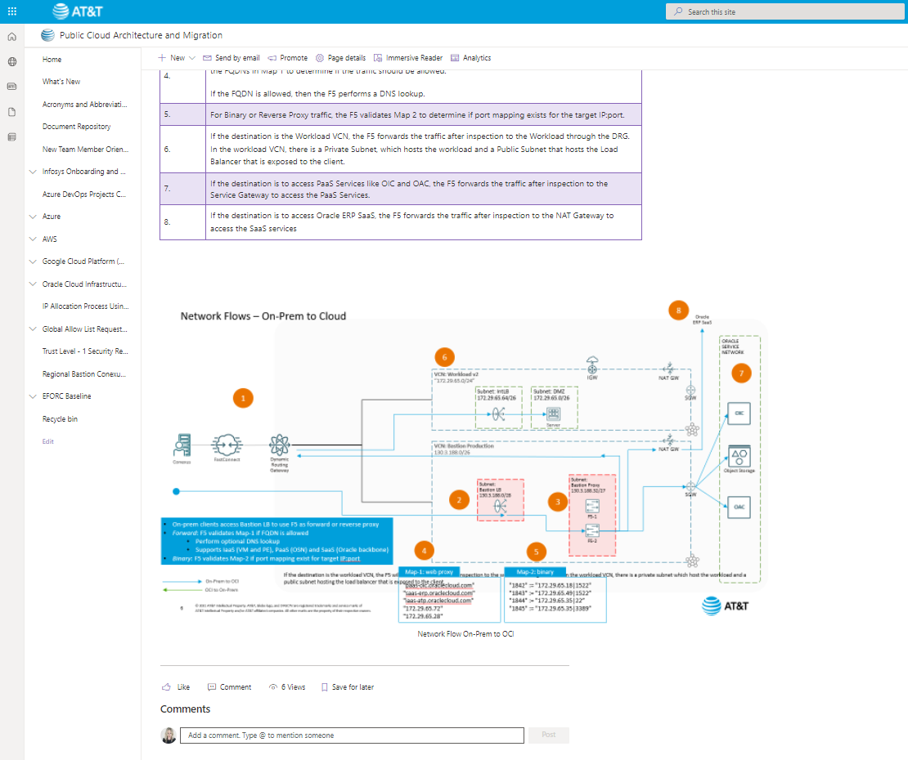

## Source Material

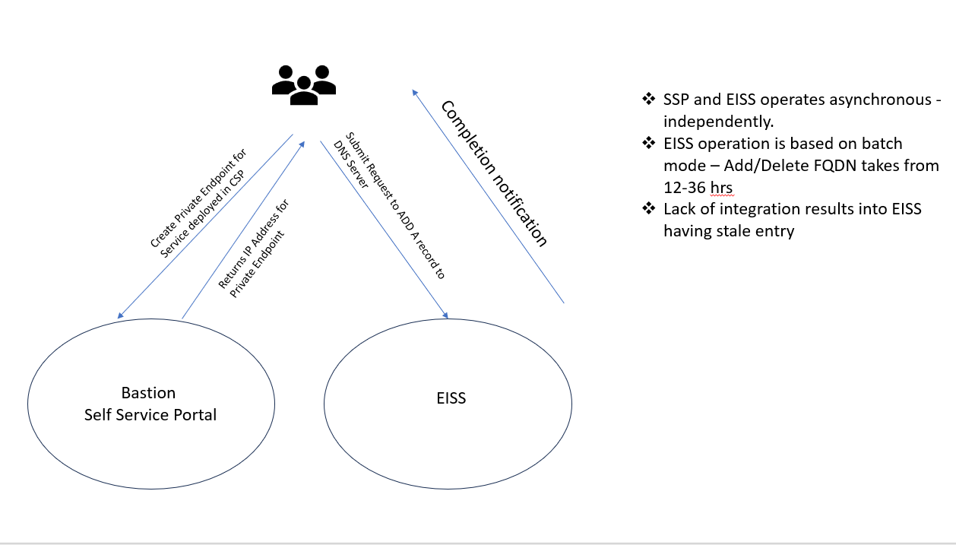

## Deliverable

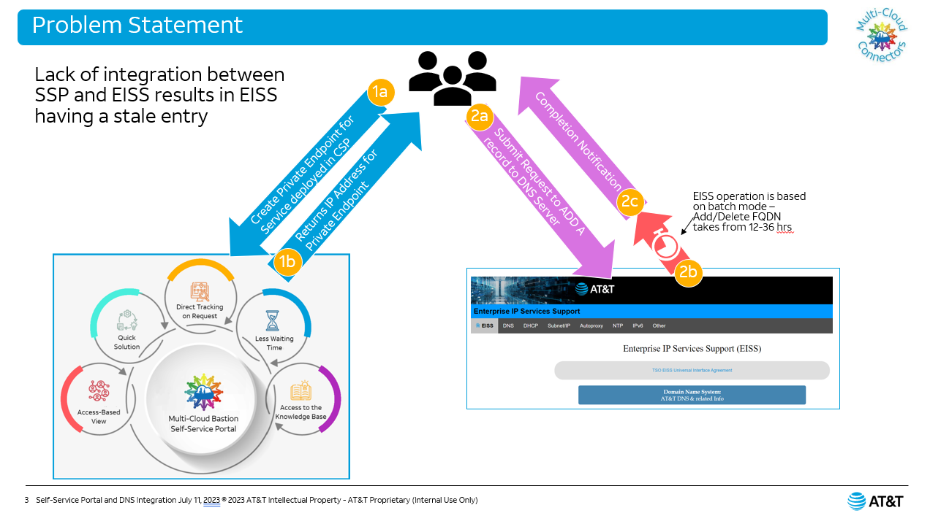

## Source Material

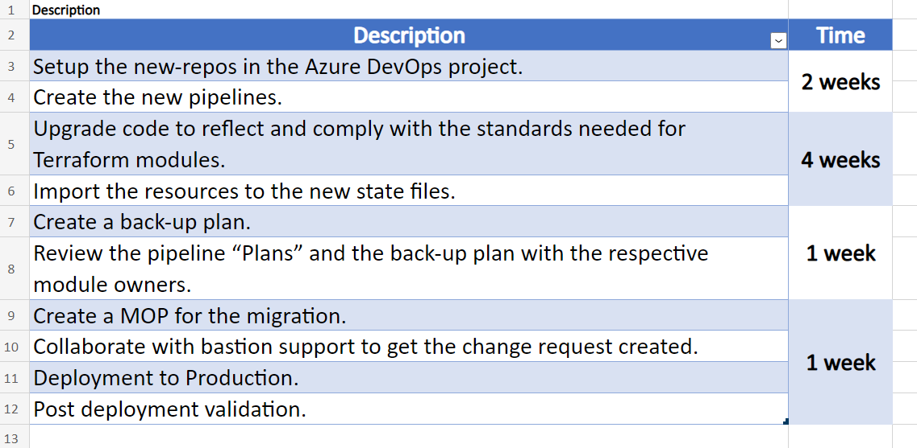

## Deliverable

